Q. Design VB.NET form application to accept and sort array in descending order.

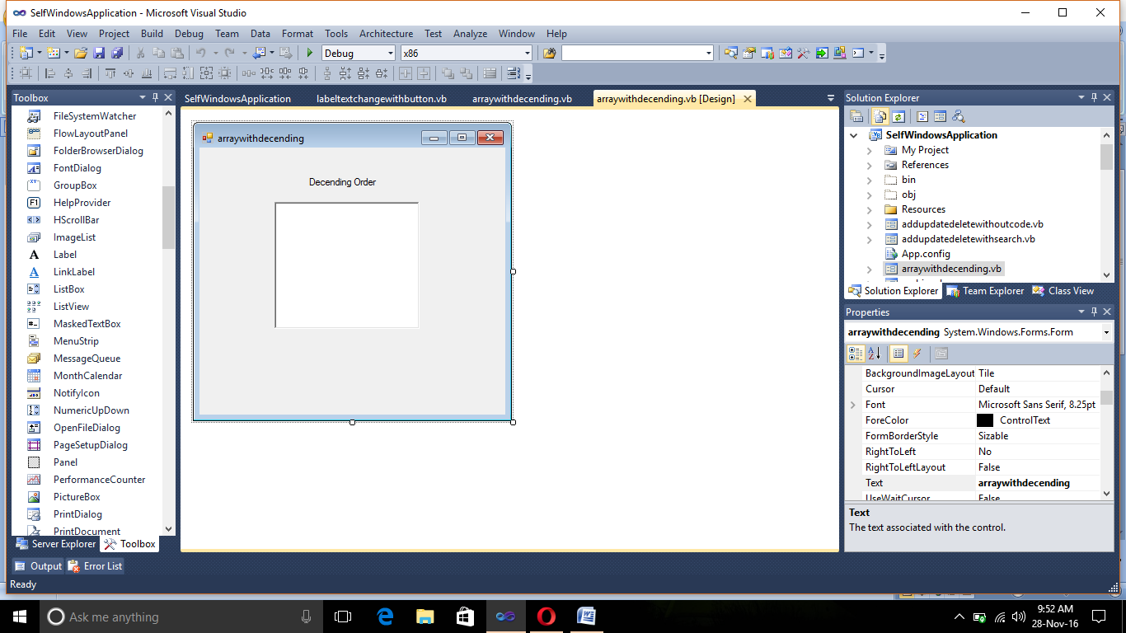

Public Class arraywithdecending

Private Sub arraywithdecending_Load(sender As System.Object, e As System.EventArgs) Handles MyBase.Load

Dim arr() As Integer

ReDim arr(5)

For i = 0 To 4

arr(i) = InputBox("Enter the elements:")

Next

For i = 0 To 4

For j = i + 1 To 4

If (arr(i) < arr(j)) Then

Dim temp As Integer = arr(i)

arr(i) = arr(j)

arr(j) = temp

End If

Next

Next

For i = 0 To 4

RichTextBox1.Text = RichTextBox1.Text + arr(i).ToString() + vbCr

Next

End Sub

End Class

